Test Case: tc003_SPX_Dev5_Crear_Requisicion_Spot_Tipo_Cobro_CC_Urgent
Step 1 - Enter username and password and click to button Enter : Credentials Entered
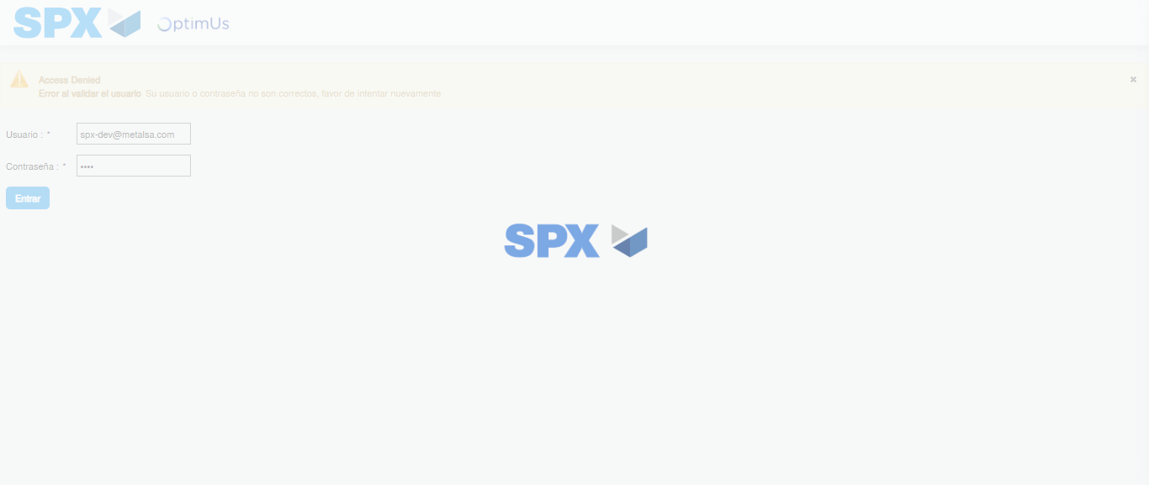Image file-name: QC_Testing-tc003_SPX_Dev5_Crear_Requisicion_Spot_Tipo_Cobro_CC_Urgent-1785959734105

Step 2 - Select to UEN and Access to Spot Buy Requisitions : UEN Correctly selected and Correct access
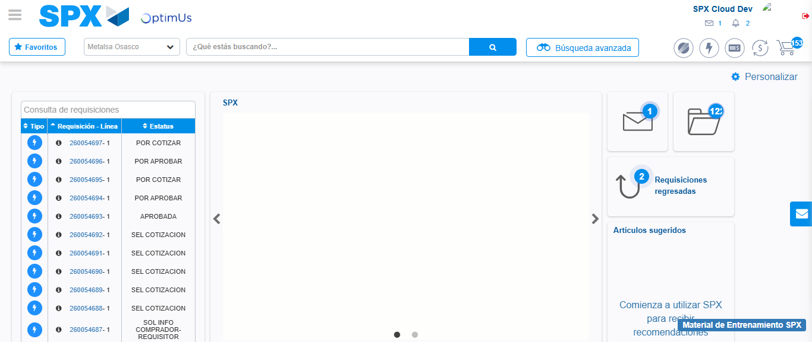Image file-name: QC_Testing-tc003_SPX_Dev5_Crear_Requisicion_Spot_Tipo_Cobro_CC_Urgent-1785959772519

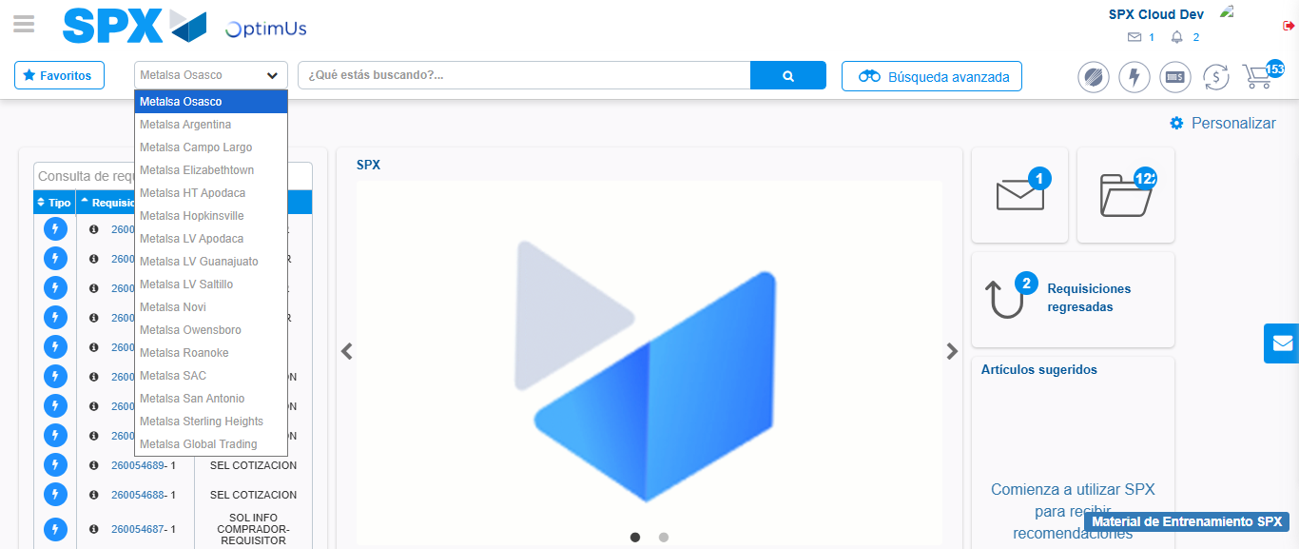Image file-name: QC_Testing-tc003_SPX_Dev5_Crear_Requisicion_Spot_Tipo_Cobro_CC_Urgent-1785959775076

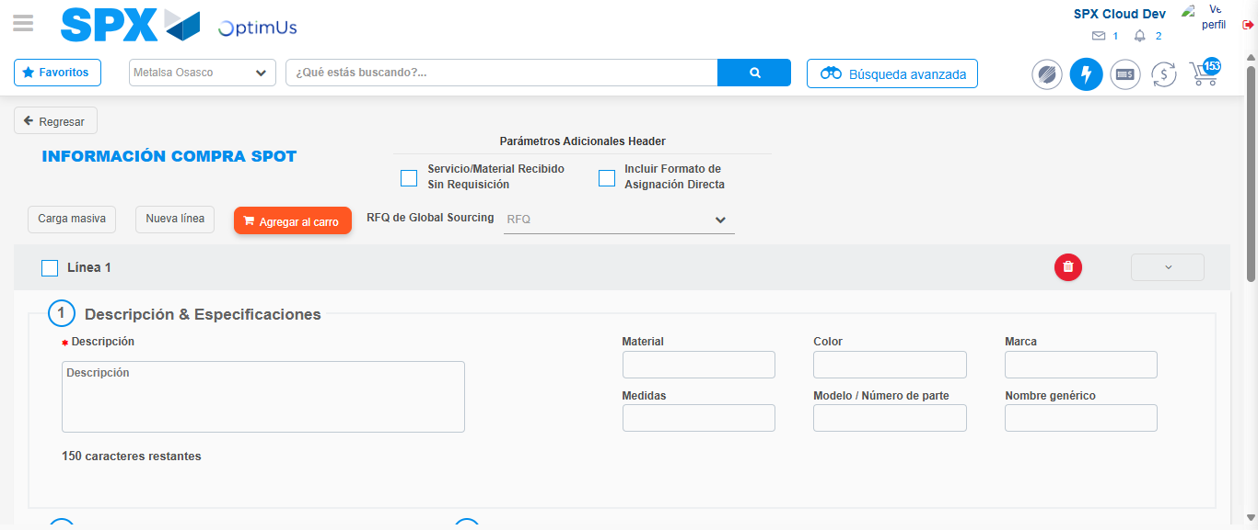Image file-name: QC_Testing-tc003_SPX_Dev5_Crear_Requisicion_Spot_Tipo_Cobro_CC_Urgent-1785959818112

Step 3 - Data Capture Spot Buy Requisition: Data captured correctly
Image file-name: QC_Testing-tc003_SPX_Dev5_Crear_Requisicion_Spot_Tipo_Cobro_CC_Urgent-1785959818346

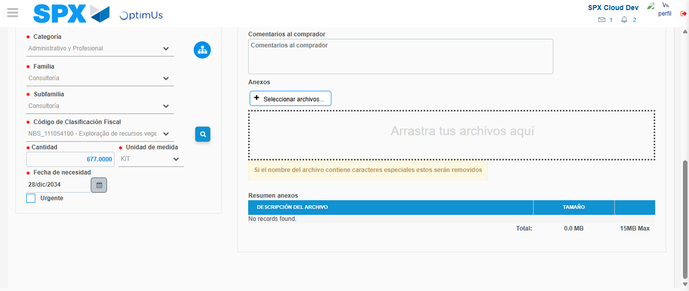Image file-name: QC_Testing-tc003_SPX_Dev5_Crear_Requisicion_Spot_Tipo_Cobro_CC_Urgent-1785959839827

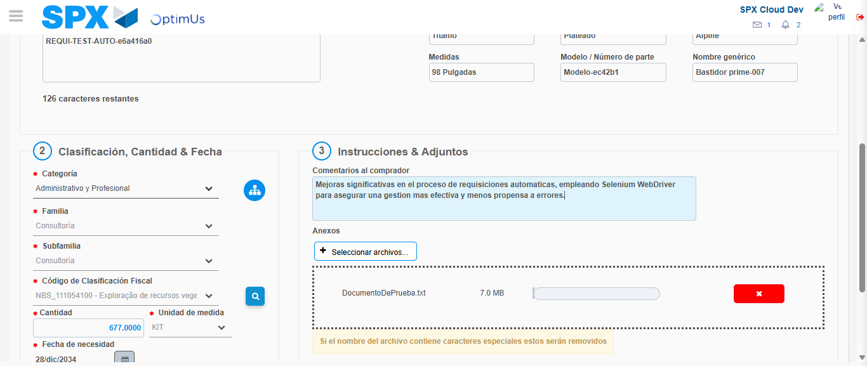Image file-name: QC_Testing-tc003_SPX_Dev5_Crear_Requisicion_Spot_Tipo_Cobro_CC_Urgent-1785959840551

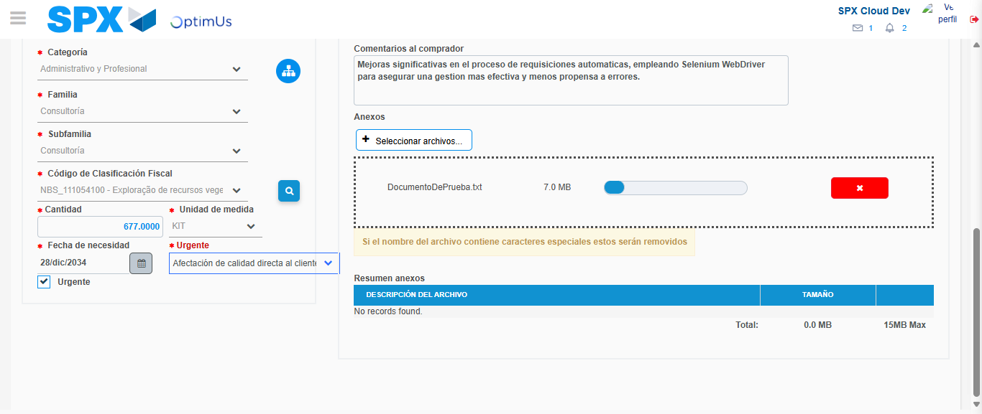Image file-name: QC_Testing-tc003_SPX_Dev5_Crear_Requisicion_Spot_Tipo_Cobro_CC_Urgent-1785959844616

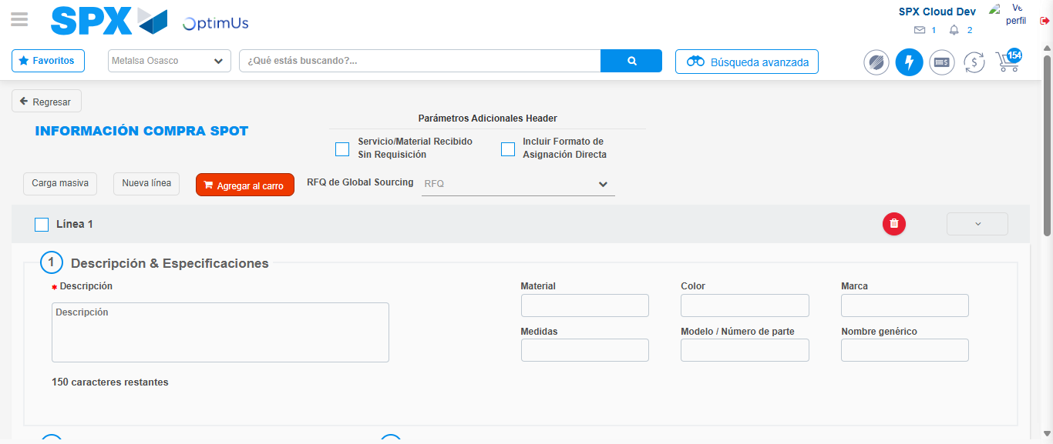Image file-name: QC_Testing-tc003_SPX_Dev5_Crear_Requisicion_Spot_Tipo_Cobro_CC_Urgent-1785959863270

Step 7 - Return to Main Page SPX : Return to Main Page SPX
Image file-name: QC_Testing-tc003_SPX_Dev5_Crear_Requisicion_Spot_Tipo_Cobro_CC_Urgent-1785959772519

Image file-name: QC_Testing-tc003_SPX_Dev5_Crear_Requisicion_Spot_Tipo_Cobro_CC_Urgent-1785959775076

Image file-name: QC_Testing-tc003_SPX_Dev5_Crear_Requisicion_Spot_Tipo_Cobro_CC_Urgent-1785959818112

Image file-name: QC_Testing-tc003_SPX_Dev5_Crear_Requisicion_Spot_Tipo_Cobro_CC_Urgent-1785959865468

Image file-name: QC_Testing-tc003_SPX_Dev5_Crear_Requisicion_Spot_Tipo_Cobro_CC_Urgent-1785959865661

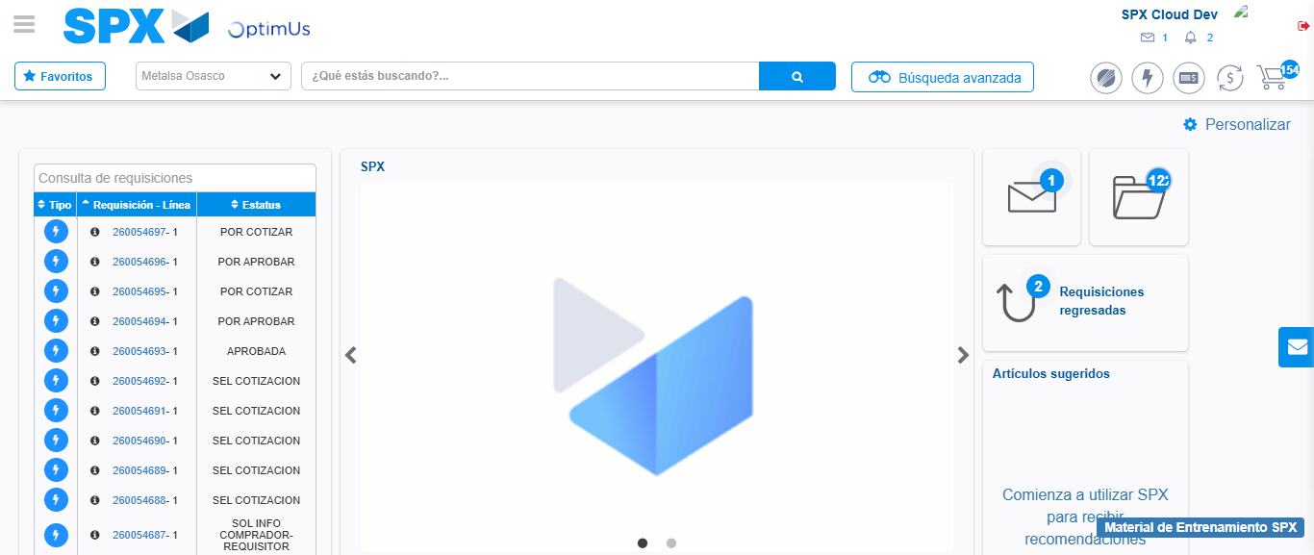Image file-name: QC_Testing-tc003_SPX_Dev5_Crear_Requisicion_Spot_Tipo_Cobro_CC_Urgent-1785959888138

Step 8 - Log Out : Log Out SPX
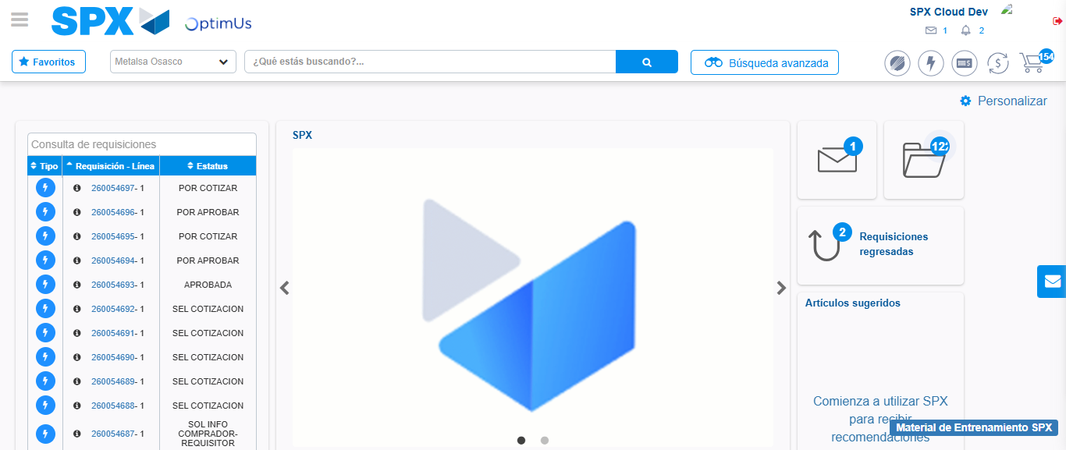Image file-name: QC_Testing-tc003_SPX_Dev5_Crear_Requisicion_Spot_Tipo_Cobro_CC_Urgent-1785959888426

